Developing a smart technology application to address Gender-Based Violence (GBV) in Harare.

Done by:

Walter Chandiringa R168783E.

Tadiwa Chimungwe R224025K

Praise Mukono R229264Z

Gamuchirai Chirata R229254Z

**Background and Justification**

Gender-based violence (GBV) is defined as harmful acts committed against a person based on their gender. This could result in physical, sexual, and psychological harm. Whether occurring in public or private life, threats, coercion, and arbitrary deprivation of liberty constitute gender-based violence. Notably, both men and women are experiencing and being affected by gender-based violence. However, most victims of gender-based violence have been women and girls. In Africa, gender-based violence is one of the numerous obstacles preventing women from exercising their fundamental rights to life, human dignity, peace, justice, socioeconomic development, and political advancement. GBV has grown more prevalence with an alarming rate with 1 in every 3 women aged between 15 to 49 having experienced physical violence and about 1 in 4 women has experienced sexual violence since the age of 15 and that’s according to WHO 2022 statistics in Zimbabwe. Women are more likely to experience violence from their intimate partners or family members.

**Objective**

The primary aim of this project is to increase women’s capacity to prevent and respond to GBV. The specific objectives could include:

1. Increasing women’s awareness of their legal rights
2. Improving women’s knowledge on types and extent of GBV and its consequences
3. Empowering women with information on available service providers for response to GBV
4. Avail counselling services to prevent GBV and to women who have experienced GBV.

**Justification**

GBV is one of the numerous obstacles preventing women from exercising their fundamental rights to life, human dignity, peace, justice, socioeconomic development, and political advancement. Despite the adoption of progressive policies and legal frameworks to eradicate GBV, it remains the most pervasive violation of human rights.

**Interventions**

For the project to work organizations representing the interests of women will be engaged. The mobile app can provide a platform for the collection of evidence as the women can upload audios and pictures of GBV which can be provided to the police as evidence. With such an app the organizations will be better placed in helping women in the sense that some women who fear to report violence can do it online if they have a mobile phone. The aim is to have more women come forward and report and help fight GBV.

**.0 Gender Based Violence App**

Gender Based Violence is an application which intends to provide a platform for victims to be able to register their credentials before using the applications, also to be able to have an eased access to authorities which may be of help in times of need. The following are the features of the GBV app

**3.1 Shortcut**

The following image is a shortcut to the GBV app which was installed on an android phone for testing purposes by the developer. It enables the user to kick-start the use of the application.

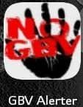

*Figure 3.1: GBV Shortcut*

**3.2 Splash Screen**

The following screen is the splash screen; it is a graphical screen which appears at the launch of the GBV application.

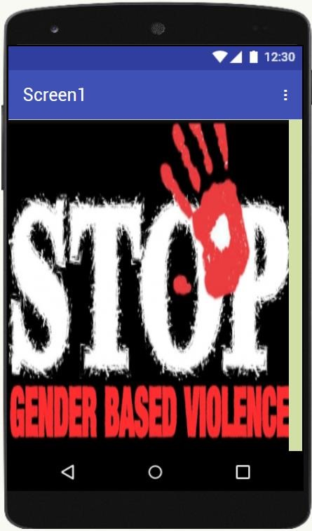

*Figure 3.2: GBV Splash Screen*

**.3 Login Screen**

This screen is responsible for validating and authenticating users who get access to the application, if a user is not registered an option for sign up is available, the screen below will be used as a security feature to allow only registered users to access the application.

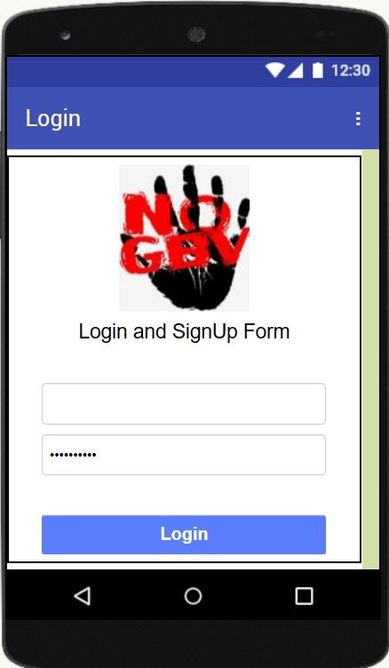

*Figure 3.3: Login/ Sign in Page*

* If someone tries to log in with the wrong user details the screen will display the following.

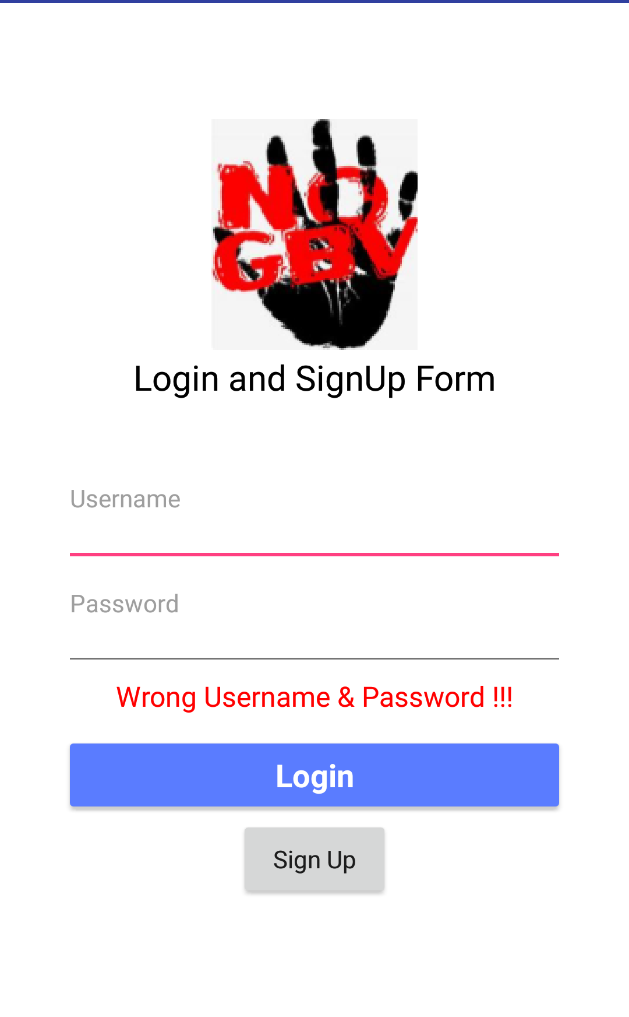*figure 3.4: wrong user details*

* New users must sign up first before they are able to log in. The user must complete or fill in all the fields before they can sign, or the screen will display the following screen.

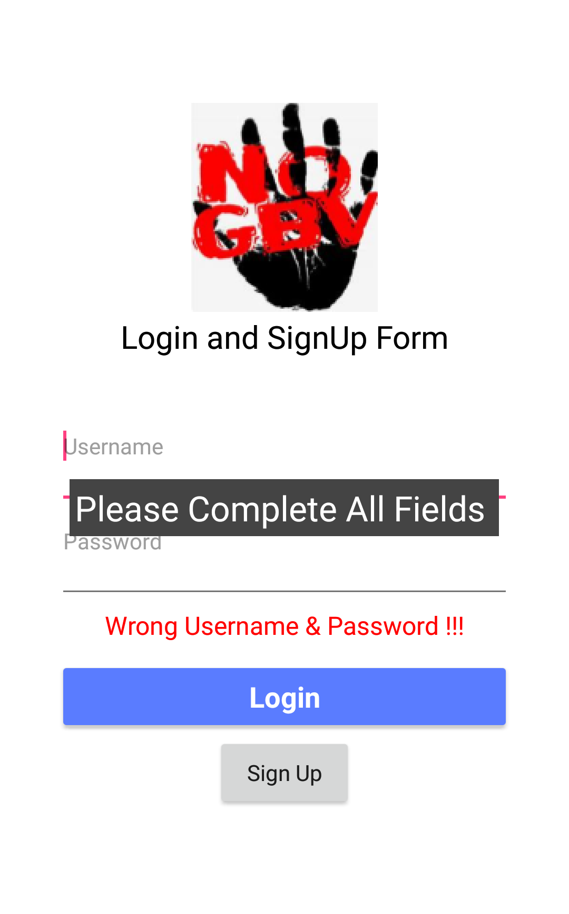

*Figure 3.5: user sign up details.*

**.4 Firebase Database**

This is the database which will be used to store user credentials for the application’s registered users, it shows the usernames and passwords of the registered users. Firebase is NoSQL cloud-based database provided by Google Firebase. It allows developers to store and synchronize data in real time, below is the image of how a firebase database environment looks like

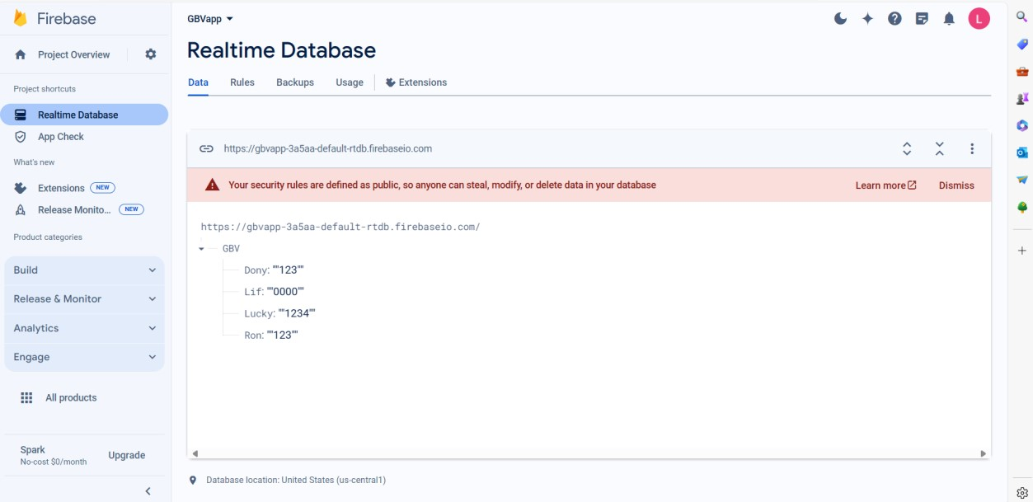

*Figure 3.6: Firebase Real-time Environment*

**.5 GBV Menu Page**

Upon accessing the system, the home page prevails, and it provides tabs to help the user to navigate the application, the image below shows the GBV Home Page

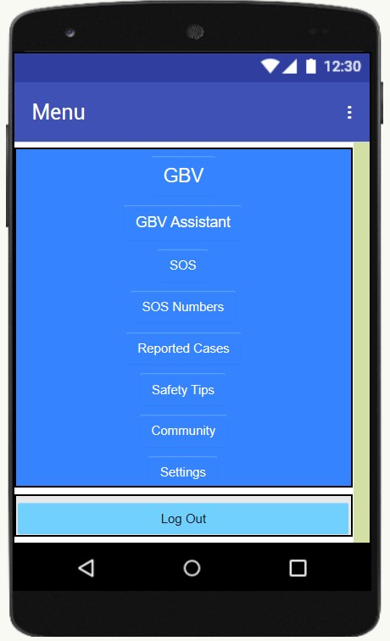

*Figure 3.5: GBV Menu Page*

**.6 SOS Tab**

SOS is an international Morse code distress signal which means “Save Our Souls”. it used to signal a life-threatening emergency in this case, we consider the user to use the SOS tab to alert the authorities responsible for helping gender-based victims in a society. The following Page shows an SOS page with two authorities which are currently being used by the developer to test the application. The developer used the NGOs and Police as the authorities which can help the GBV victims, the numbers of these authorities are embedded in the system and can be always updated by the administrator in case of change of personnel due to varied reasons. For testing purposes, Mr Mutindindi has been assigned as Police and Dr Masunda as an NGO Member, the user will have to press the call button to make a call and direct calls to respective numbers are initiated for help.

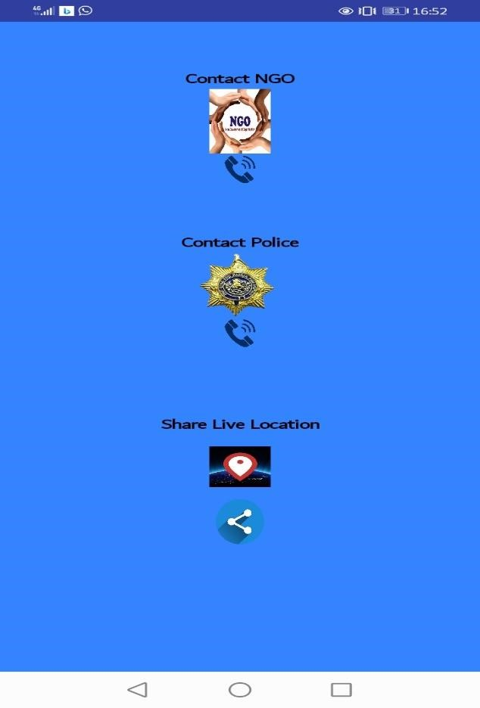

*Figure 3.6: SOS Page*

3.7. **GBV ASSISTANCE Tab.**

The GBV assistance tab stands for gender-based violence assistance. It is used by users to find a help centre which is near them by giving them directions to the nearest GBV help centres using a map, like Msasa project, Pamuhacha and Fawezi which have been embedded for testing purposes, these help centres. By clicking on the GBV assistance tab it will display the following screen first.

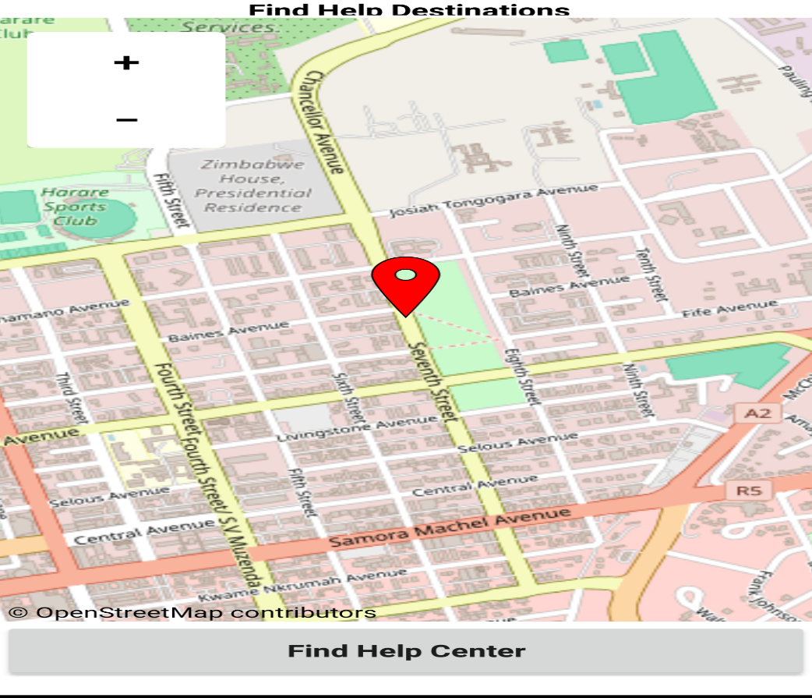

*Figure 3.8: GBV assistance tab.*

* The next step will be to click on the find my help centre button to find out the assistance centres available to them. The screen will display the following.



*Figure3.9: help centres*

* The next step will be to click on the chosen help centre, and it will give you directions on how to get to the destination. For click on the PaMuhacha Goromonzi centre it will display the following on the screen.

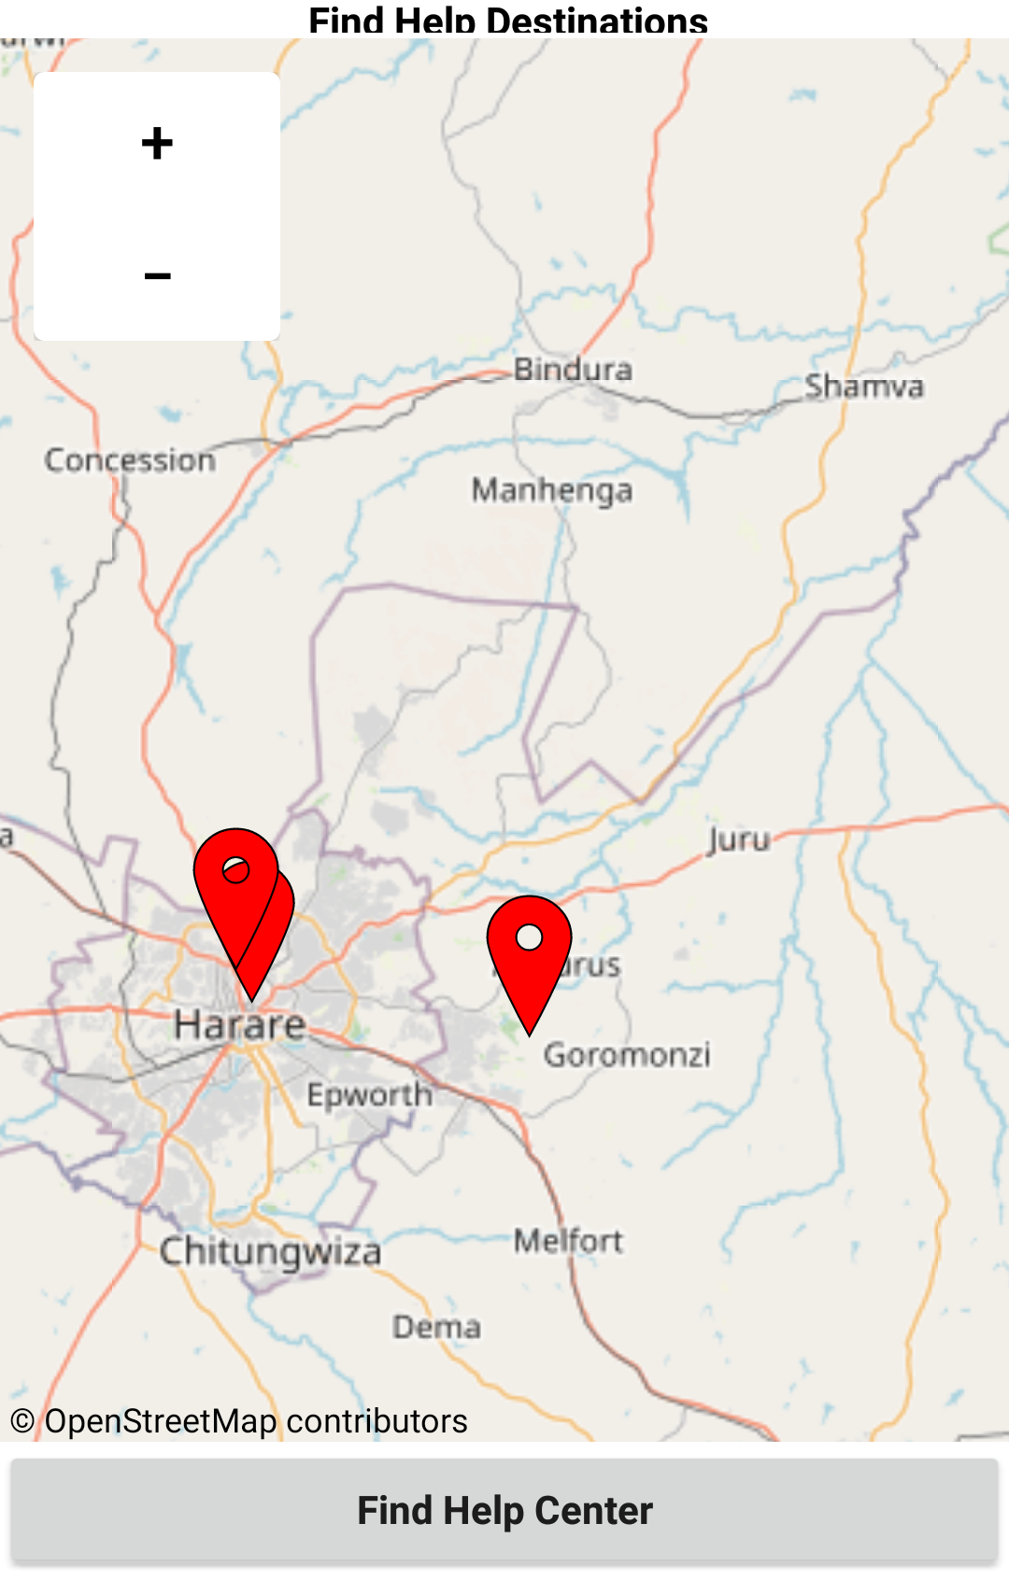

*Figure 3.10: help centre directions*

**4.0 Future Tasks**

The developer is looking forward to accepting various contributions from the team he is working with and, there are pending tasks on the two applications which need to be perfected.

**4b. 1 Gender Based Violence App**

The application has the following tasks pending:

* A lot of modules have not yet been done, with the login and sign-up module done and the SOS as well, functioning properly, the developer is looking forward to developing a Gender based Assistant which is a Gender Based Chabot which will be embedded on the GBV App
* The developer also seeks to develop the Community platform for Gender Based Violence Victims
* The developer also seeks to provide a page which will empower the users of the application with safety tips upon encompassing a gender-based circumstance.
* A provision of additional SOS numbers will be added to the application for users to have more reliable personnel to base on in case the ones embedded on the app aren’t getting through for help.
* A live location module will need to be added, where the user can share location where a GBV circumstance is happening for authorities like police to be able to help, or a nearest NGO facility where the GBV victims can rely on for help.